AI Music App (iOS)

This is the summary for this project development process.

We will follow these steps:

1. User Interface:

- Start by creating a visually appealing and intuitive user interface.

- Use a clean and modern design that is consistent with the app's purpose.

- Implement easy-to-use navigation to ensure smooth user experience.

2. Registration/Login:

- Allow users to register or log in using their preferred method, such as email, social media accounts, or phone numbers.

- Ensure proper security measures for user authentication and data protection.

3. Home Screen:

- Create a home screen with a welcoming interface and clear options for the user.

- Include options to create a new music track, access previous projects, and browse saved projects.

4. Creating a New Music Track:

- When the user chooses to create a new music track, provide options for script writing using ChatGPT4.

- Implement a text editor where users can write their scripts or provide prompts, which will be used to generate the lyrics or story for the music.

- Integrate the ChatGPT4 API to process the user's input and generate creative scripts.

5. Background Music Creation with Soundful:

- Allow users to customize the background music for their tracks.

- Integrate the Soundful API to offer a range of music genres, styles, or moods for the users to choose from.

- Provide options to adjust the tempo, intensity, or other aspects of the background music.

6. Vocal Track Creation with Elevenlabs:

- Enable users to create vocal tracks for their music.

- Integrate the Elevenlabs API to generate vocal tracks based on the user's script or lyrics.

- Provide options to adjust the vocals' tone, pitch, or style.

7. Mixing and Rendering:

- Once the user has inputted their desired scripts, background music, and vocal tracks, proceed to mix and render the final music track.

- Develop an algorithm or use audio mixing libraries to combine the different elements seamlessly.

- Provide options for the user to adjust the audio levels, effects, or any other preferred customizations.

8. Saving and Sharing:

- Allow users to save their completed music tracks within the app.

- Implement features to easily share the created tracks on social media platforms or through messaging apps, if desired.

9. Settings and Preferences:

- Include a settings section where users can configure their preferences, such as language, notifications, or account details.

- Allow users to personalize their app experience by customizing themes, fonts, or other visual aspects.

10. Testing and Refinement:

- Thoroughly test the app's functionality, interface, and integrations to ensure a smooth user experience.

- Collect user feedback and make necessary improvements or updates based on their suggestions.

My proposal :  
15000$, 3-4 months

In fact, It’s not basic app but with my expertise and experience, I believe that I can bring the perfect result within more less time and budget.

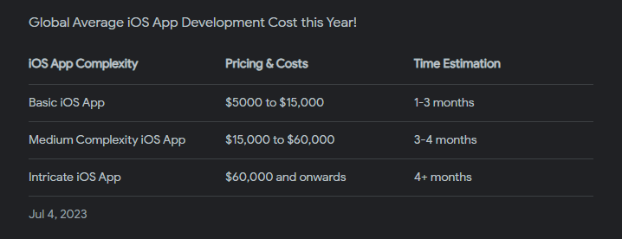

If you are interested in pursuing this project further and would like to discuss more details, please reach out to my email (michael.edy623@gmail.com).

Hope to hear from you soon.

Thank you!